

**Audi Global Sales & Tax Analysis Dashboard**

This dashboard provides a comprehensive analysis of Audi’s global vehicle sales, tax contributions, and fuel-transmission trends, derived from multi-year data across major world regions.

**Tools & Technologies Used:**

* **Power BI** – Interactive dashboard and visualization.
* **Python** – Data preprocessing, transformation, and automation.
* **Excel** – Raw data formatting and cleaning.
* **DAX** – Custom measures, KPIs, and logic in Power BI.

**🟩 Power BI**

* **Dashboard Design:** Created interactive and visually rich dashboards with slicers for **Year** and **Region** filters.
* **Visuals Used:**
  + 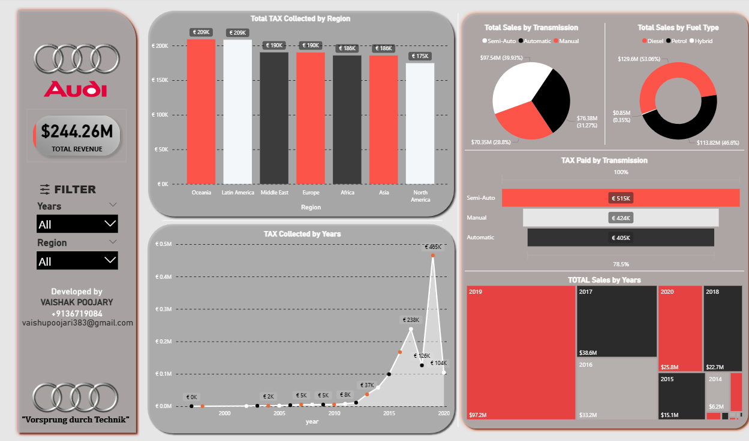Bar Charts (Tax by Region)
  + Line Chart (Tax by Year)
  + Pie Charts (Sales by Fuel Type & Transmission)
  + Stacked Bars (Year-wise Sales, Tax by Transmission)
* **Custom Measures:** Implemented using **DAX** to calculate:
  + Total Sales
  + Tax Paid by Transmission
  + Sales % Share by Category
* **Data Transformation:** Used **Power Query Editor** to clean and shape data:
  + Removed nulls
  + Changed data types
  + Created new columns

**🐍 Python**

* **Libraries Used:**
  + pandas – for reading CSV data and early data inspection
  + matplotlib – for basic exploratory visualization (optional/initial phase)
* **Script Functionality:**
  + 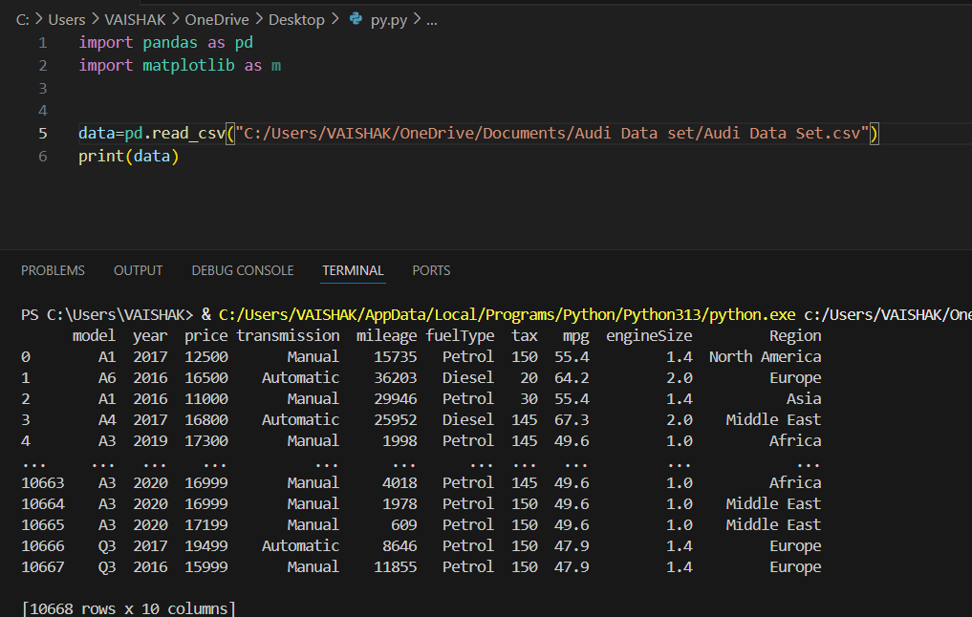Loaded dataset of **10,668 rows × 10 columns**

**🟩 Power BI Representation**

**Objective:** Build an interactive dashboard to analyze Audi's sales, tax contributions, and trends across years and regions.

**Power BI Highlights:**

* **Visual Elements:**
  + **Bar Charts**: Total Tax by Region & Year
  + **Pie Charts**: Sales by Fuel Type & Transmission Type
  + **Stacked Bars**: Tax by Transmission & Sales by Year
* **Interactive Filters:**
  + Year filter (2010, 2020, etc.)
  + 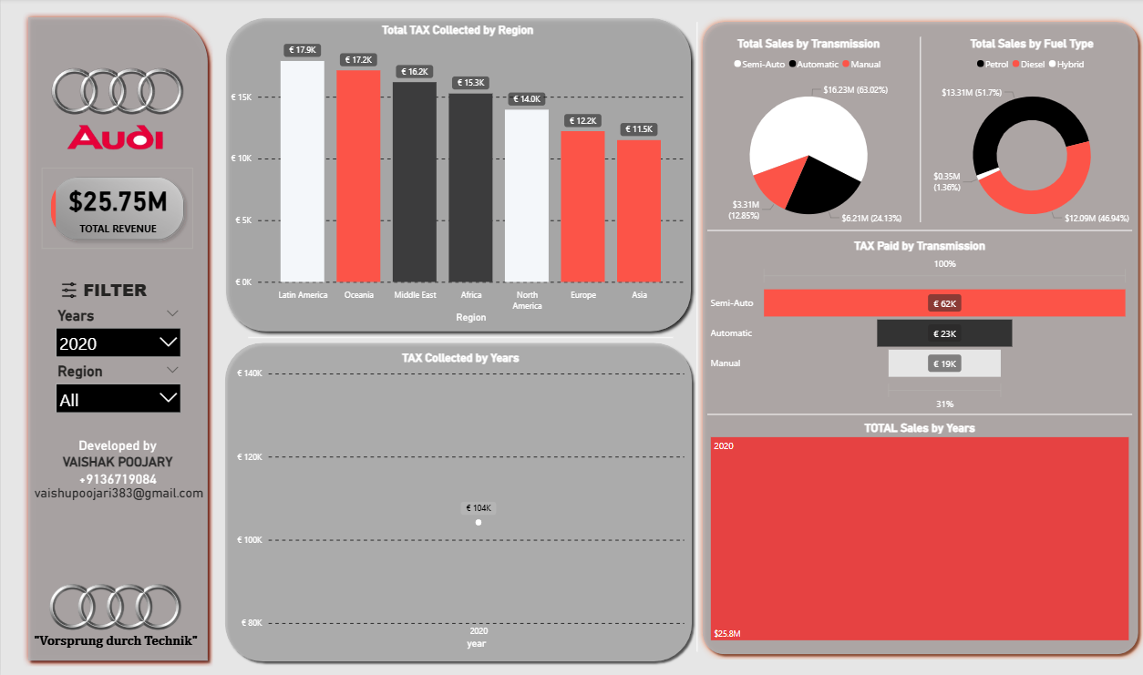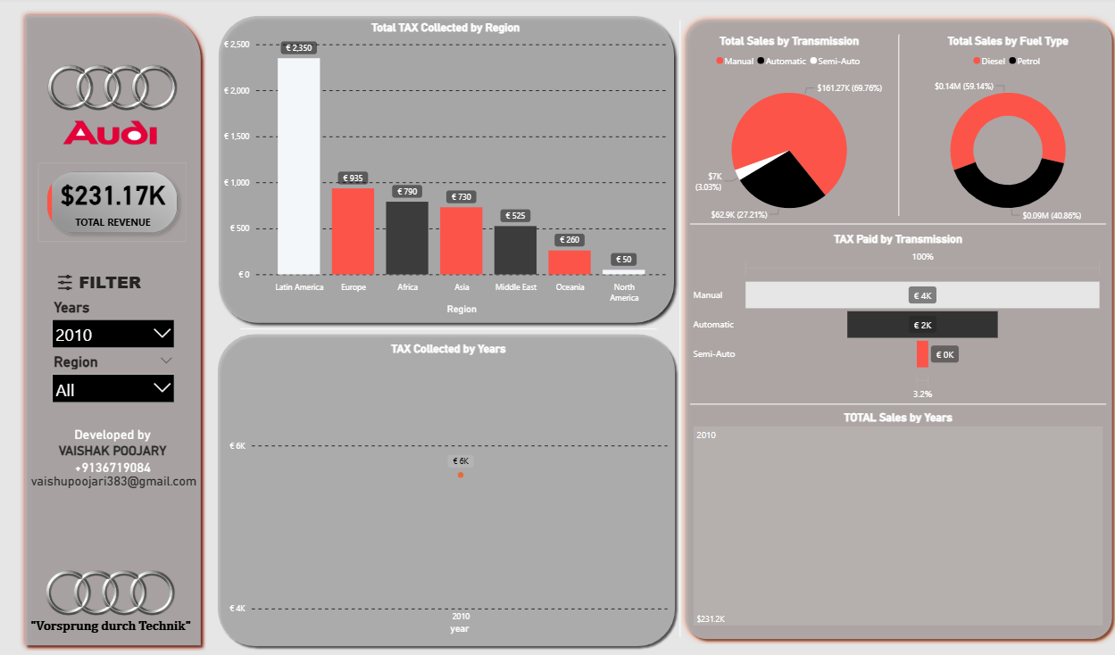Region filter
* **Custom Metrics Using DAX:**
  + Total Revenue
  + Total Tax Collected
  + Sales Distribution % by Transmission and Fuel Type
* **Design Style:**
  + Grey background with red, black, and white color scheme inspired by **Audi’s branding**
  + Cards and dynamic slicers to enhance user interaction

**Sample Insight:**

In 2020, revenue dropped to $25.75M with highest tax contributions from **Latin America (€17.9K)** and **Oceania (€17.2K)**. Semi-Auto transmission paid the most tax (€62K).

**🐍 Python Representation**

**Objective:** Perform backend data analysis and create custom visualizations that mirror Power BI outputs.

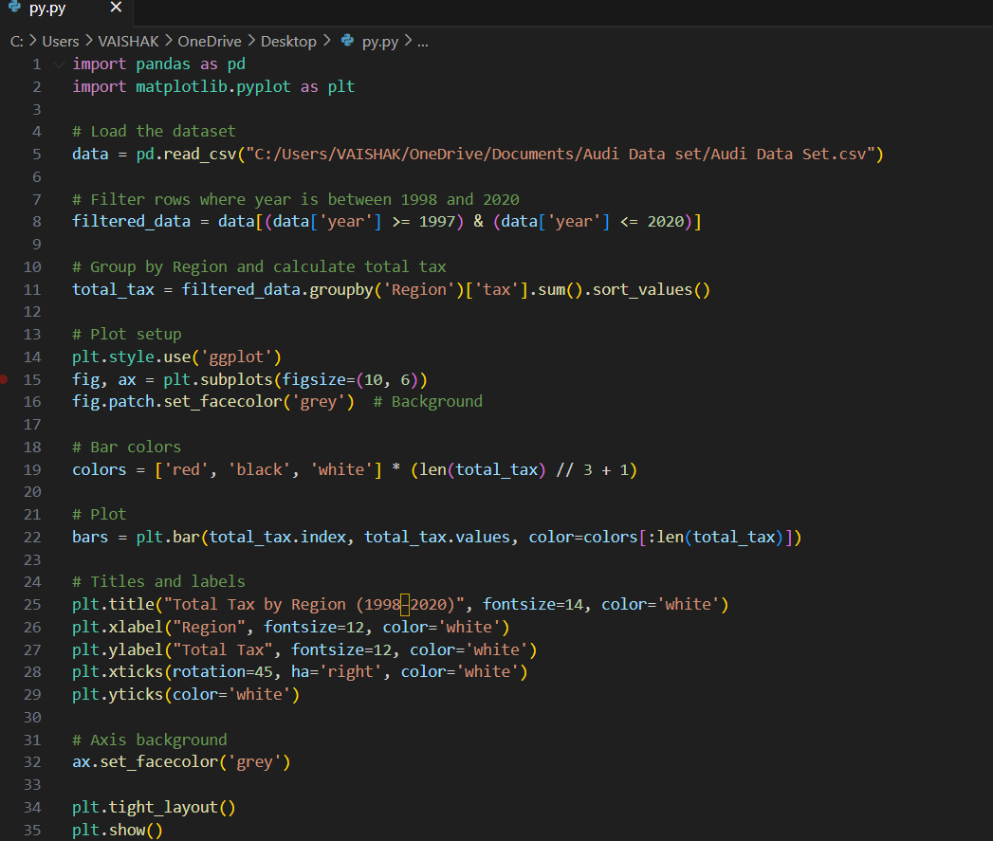**Python Visualization Summary:**

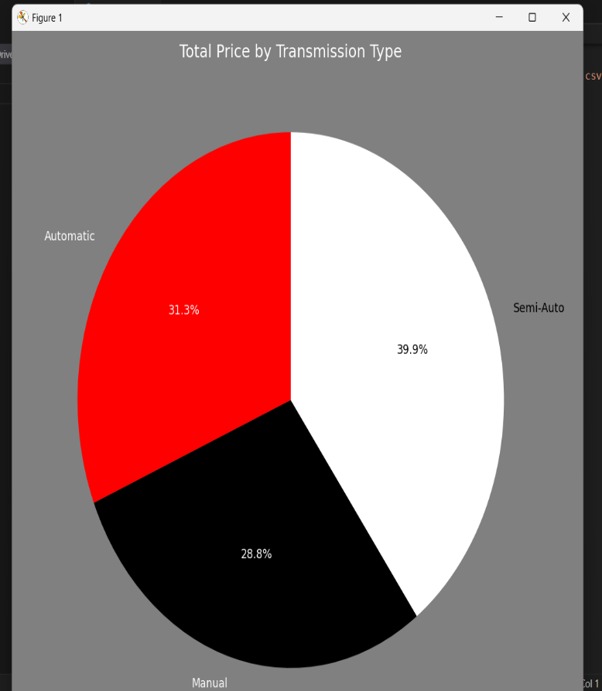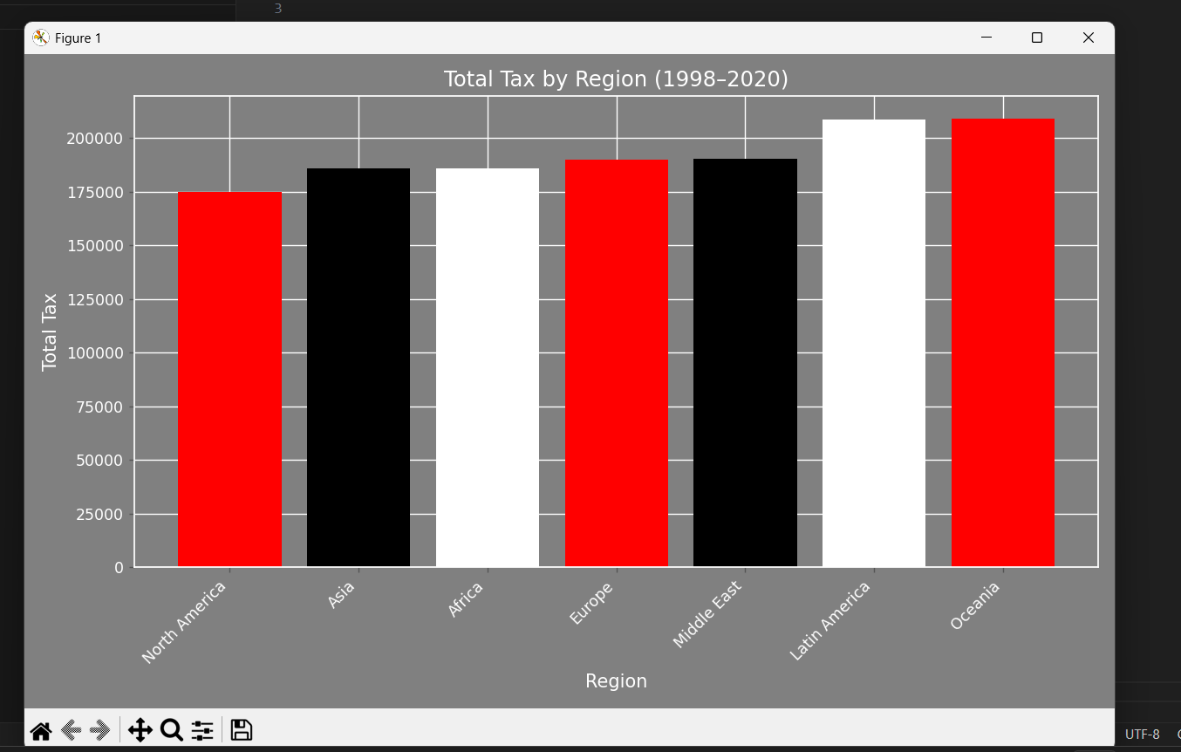

* Created a **custom bar chart** using matplotlib to represent **Total Tax by Region (1998–2020)**.
* Applied a professional theme:
  + **Grey background** for consistency with Power BI
  + **Red, black, and white bars** matching Audi colour palette
  + White-labelled axes and rotated x-axis for clarity
* Used plot style and layout enhancements for a clean, presentation-ready output

**✅ Conclusion**

The Audi Global Sales and Tax Dashboard project delivers comprehensive insights into Audi’s market performance across multiple dimensions including **region, year, fuel type, and transmission type**. Utilizing **Power BI** for interactive visualizations and **Python** for analytical plotting, the project bridges business intelligence with data science.

Key takeaways:

* **2019** marked the highest revenue year.
* **Oceania** and **Latin America** contributed the most in total tax.
* **Diesel fuel** and **Semi-Auto transmission** led in sales performance.

This project supports data-driven decision-making in marketing strategy, product focus, and regional operations for the automotive sector.

**👤 Presented By:**

**VAISHAK POOJARY**  
📞 +91 936719084  
📧 vaishupoojary383@gmail.com  
🔗 [LinkedIn](https://www.linkedin.com/in/vaishak-poojary/)  
💻 [GitHub](https://github.com/VaishakPoojary)